Investment programme for state-owned transport infrastructure network for 2023-2030

Summary

What is the transport network investment programme all about?
As part of the implementation of the National Transport System Plan (Transport 12), the Finnish Transport Infrastructure Agency has prepared a second 8-year investment programme for the state-owned transport infrastructure network. The investment programme presents the most important transport infrastructure projects for the next few years. The Finnish Transport Infrastructure Agency updates the investment programme annually. The investment programme for 2023-2030 is a proposal based on the Finnish Transport Infrastructure Agency's information on the implementation of new rail, road and waterway projects and their impacts.
The transport infrastructure investment programme includes development projects, major renovation projects and project packages as well as small-scale projects to improve basic transport infrastructure. The programme also includes proposals on projects funded with EU support or jointly with urban regions or the business community. The projects presented in the investment programme are divided into two categories based on how ready they are for implementation, and their urgency and impact. The projects in the project category 1A are in sufficiently advanced stages of planning for making decisions or they are otherwise urgent. The projects in the project category 1B still require further planning before decisions can be made on them.
The financial framework for the investment programme is based on the Transport 12 plan. Approximately EUR 2.7 billion is available for the investment programme’s new development investments. Of this funding, approximately EUR 1.1 billion is allocated to roads, EUR 1.5 billion to railways and EUR 0.08 billion to waterways. Approximately EUR 727 million is available for small projects to improve basic transport infrastructure, of which EUR 300 million is allocated to roads, EUR 402 million to railways and EUR 25 million to waterways. The project packages for all transport modes are based on the development and improvement themes and their shares of the funding presented in the Traffic 12 plan.
Results of impact assessments and overall impacts guide the project category selection
The investment programme has been prepared using impact assessment and knowledge-based decision-making related to it as part of the process. Continuous impact assessment was utilised while the investment programme was being formulated, which ensured that the information produced in the assessment would support the prioritisation of projects and their transparency. The impacts of the investment programme were assessed at three levels: 1. project level; 2. transport mode level; and 3. the whole investment programme level. A versatile and extensive impact assessment highlights the significant impacts of the investment programme while also assessing how the objectives of the Transport 12 plan will be met.

The investment programme’s overall impact assessment highlights impact chains and interdependencies between different perspectives, and conclusions are drawn on the overall impacts of the investment programme.
The projects included in the investment programme have been prioritised taking account of the results of the impact assessment of the programme, i.e., project-specific project evaluations and the overall impacts of the programme, the impacts in relation to the Traffic 12 objectives, the other Transport 12 plan policies and the needs identified in the strategic situational picture of the transport network.
The project package included in the investment programme will improve the cost-effectiveness and predictability of business transport. Travel times for passenger transport will be reduced and travelling will become more predictable, smoother and safer. While the direct climate impacts of the investment programme are small, improving transport efficiency and possible transitions from one mode of transport to another will reduce climate emissions in the longer term.
The investment programme will significantly improve road safety. The level crossings to be removed or improved on the railway network will also contribute to improved road safety. Waterway projects will improve vessel traffic safety, thus also reducing the environmental risks to waters.
In the projects for Southern Finland, the emphasis is on the benefits achieved through improved safety and accessibility as regards commuting and recreational travel. In the projects for Eastern Finland, the focus of sustainability benefits is on the environment and health. In Western Finland, the benefits from the projects will be fairly evenly distributed between the different target areas. In Northern Finland, the projects will bring accessibility benefits, especially as regards boosting of business life. Most of the project benefits will be enjoyed by the regions neighbouring the sites where the projects are implemented. In urban projects, the tendency of the benefits to concentrate locally is explained by such factors as a dense urban structure. On the other hand, in projects that are typically located on line sections and fairway sections with a lot of long-distance traffic, the benefits are distributed over a very large area in Finland.
The project package of the railway network is formulated through long-term planning
The financial framework for developing the railway network for the investment programme period 2023–2030 is EUR 1,469 million. The development themes for the railway network concern the functioning and capacity of the railway network, connections between regional centres, station areas and railway yards, as well as measures taken outside the arterial rail network. The development themes also take a stand on how funding is to be allocated to arterial railways and the other rail network. The emphasis is on the arterial railways. In practice, the majority of development projects are linked to several different themes.
Rail projects will ensure the service level of the existing network and create preconditions for increasing passenger and freight traffic and, to some extent, commuter rail traffic in urban areas as well. The projects will improve the cost-effectiveness and functionality of transport and create preconditions for increasing the number of rail transports. The accessibility and service level of urban areas will improve, which will consequently improve the opportunities to develop land use. The impacts on greenhouse gas emissions and safety are minor but positive.
Projects have been excluded from the programme, for example, due to unspecified project content, low impact or uncertainties related to the operating environment, traffic or impacts. In part, the needs must be compared and assessed further from the perspective of the entire railway network's needs. Not all funding allocated to development has been committed in the programme. One of the reasons for this is that the operating environment changed significantly in spring 2022, when Russia invaded Ukraine. The starting points and needs of the projects related to Russian transport have changed. Due to the situation, transport flows and volumes on the rail network are undergoing change, and there may be additional changing needs for the rail network. Changes in the operating environment and the needs concerning the railway network require monitoring. Although we are identifying growing and emerging needs, it is still necessary to define the measures and assess costs and impacts related to these needs before they can be treated as real potential projects to be included in the investment programme.
Track renovations will be carried out with funding for basic infrastructure management, and, with the exception of some projects proposed for development, they will not be addressed in the investment programme. The need for annual funding will increase over the next ten years due to the ageing of infrastructure, an increase in cost levels and, to some extent, the increase in the amount of railway property. Maintaining the current service level of the railway network alone requires significant investment. Renovations are also often done to improve the service level.
Projects for improving basic infrastructure management promote sustainable mobility in urban areas in particular, and improve the level crossing safety, the loading areas of raw wood, and the functionality of line sections and railway yards.
The road network would require many times more projects than can be included in the programme
The central government financial framework for developing the road network for the investment programme period 2023–2030 is EUR 1,136 million. The total costs of road development projects included in the programme are slightly higher than the financial framework, as some of the projects also include non-state contributions. The development themes for the road network concern developing the major arteries, improving the operating preconditions of businesses with other networks, and the participation of the state in supporting the development of businesses and land use in municipalities other than those located in MAL regions, on a co-funded and contractual basis.
The financial framework for projects to improve basic transport infrastructure management is EUR 300 million, of which a total of approximately EUR 40 million has been committed to projects already decided upon. In the investment programme, approximately EUR 95 million of uncommitted funding for projects to improve basic transport infrastructure management will be allocated to named improvement projects for 2023–2030. The remaining EUR 165 million will be allocated later to sites that promote traffic safety, smoothness of travel, walking and cycling, and park-and-ride facilities.

Most of the programme funding is allocated to the major arteries. The service level deficiencies in the arterial roads will be rectified by means of both large development projects and intermittent projects around Finland. This ensures that the projects selected for implementation will include the most effective major development projects and a large number of smaller improvement measures in a regionally comprehensive manner.
The rest of the road network funding is allocated to the repair of large and medium-sized critical bridges whose funding from the allocations for basic infrastructure management is not realistic. The programme also includes smaller projects to maintain or improve traffic safety and service levels.
Road projects in other than MAL regions consist of sites where the actors in the area could have an interest in contributing to the costs of implementation. No agreements on the division of costs in projects have been made yet. This entity also includes the development of regional bicycle road networks and quality corridors on the fairway network maintained by the state.
The significant impacts of road projects mainly affect accessibility factors (speed, smooth and undisturbed traffic flow) and, consequently, the service level of journeys and transport (user benefits).
The project package for the waterway network covers well acknowledged needs
The development of waterways enables significant industrial investments and the related growth in maritime transport. The central government expenditure during the planning period amounts to approximately EUR 130 million. The financial framework for the development of waterways for the investment programme period 2023–2030 is EUR 83 million. For waterways, the investment programme is not expected to include projects that will continue after 2031.
The state develops the operating conditions for shipping by ensuring that the safety equipment is in appropriate condition and by adding intelligent safety devices to merchant shipping routes, especially in areas where marine automation is being developed. The costs of renovating and improving waterways during the planning period total approximately EUR 214 million, of which the average share of improvements is approximately EUR 3 million per year.
Rapid changes may occur in potential projects due to decisions made by the business sector, which may significantly change the prioritisation and scheduling of projects. The security situation in society and the related measures as well as changes caused by, for example, a sharp drop in transit traffic may also have an impact on the prioritisation and implementation of projects. This has particularly impacted the presentation and scheduling of projects towards the end of the programme period.
Waterway projects improve the service level and cost-effectiveness of transport in Finland's foreign trade. The project package supports the operating conditions of Finnish businesses and thus generates long-term income for the national economy. In the short term, central government expenditure will be incurred.
The investment programme will make maritime transport more efficient by making it possible to use larger vessels on the waterways. This will reduce emissions per tonne transported, which supports Finland's emission reduction targets. Waterway projects support the operating conditions of the business sector, thus improving employment in different regions of the country. The project package will improve and ensure vessel traffic safety.
The investment programme provides improved CEF funding opportunities for projects
The European Union's CEF programme finances projects targeted for the Trans-European Transport Network (TEN-T). The investment programme identifies transport infrastructure projects for which it is possible to apply for CEF funding after the national funding decisions have been made.
According to the preliminary assessment, the investment programme will include eight railway projects, five road projects and three waterway projects, whose planning and/or implementation could be eligible for CEF funding. In addition, the investment programme includes projects that are eligible for the CEF application process related to military mobility.
In the appendix, information on co-funded projects in MAL urban regions
The funding of EUR 661 million in accordance with the Transport 12 plan includes the central government funding for the measures of the next two MAL agreement rounds in all MAL regions.
The report “Co-funded projects in MAL urban regions” provided as an appendix to the investment programme compiles information on possible co-financing projects targeted for the state-owned transport network. These projects are not included in the investment programme as there is no knowledge of allocations available for them. The co-funded projects of MAL urban regions and the division of their costs are defined in separately negotiated agreements between the state and municipalities.
Implementation of the investment programme is monitored annually
Parliament decides on to what extent the development projects listed in the investment programme will be carried out when they decide on the state budget. Decisions on smaller improvement projects are made by the Finnish Transport Infrastructure Agency and regional ELY Centres. The implementation of the investment programme is monitored annually, and the results of the monitoring are utilised in the annual update of the investment programme. Monitoring provides information on the implementation of the investment programme and the projects and funding level presented in it.
In the central government spending limits decisions 2022–2025 and 2023–2026, a decision was made to reduce the spending limits of development projects in 2023–2026. At the moment, the appropriation according to the budget and spending limits decisions for 2021–2026 is approximately EUR 280 million less than the financial framework of the Transport 12 plan. As a result, some of the projects in the investment programme will not be implemented or will only be implemented after the programming period. Consequently, the impacts of the programme will also be realised in some respects later than estimated, and not all impacts will be fully realised.
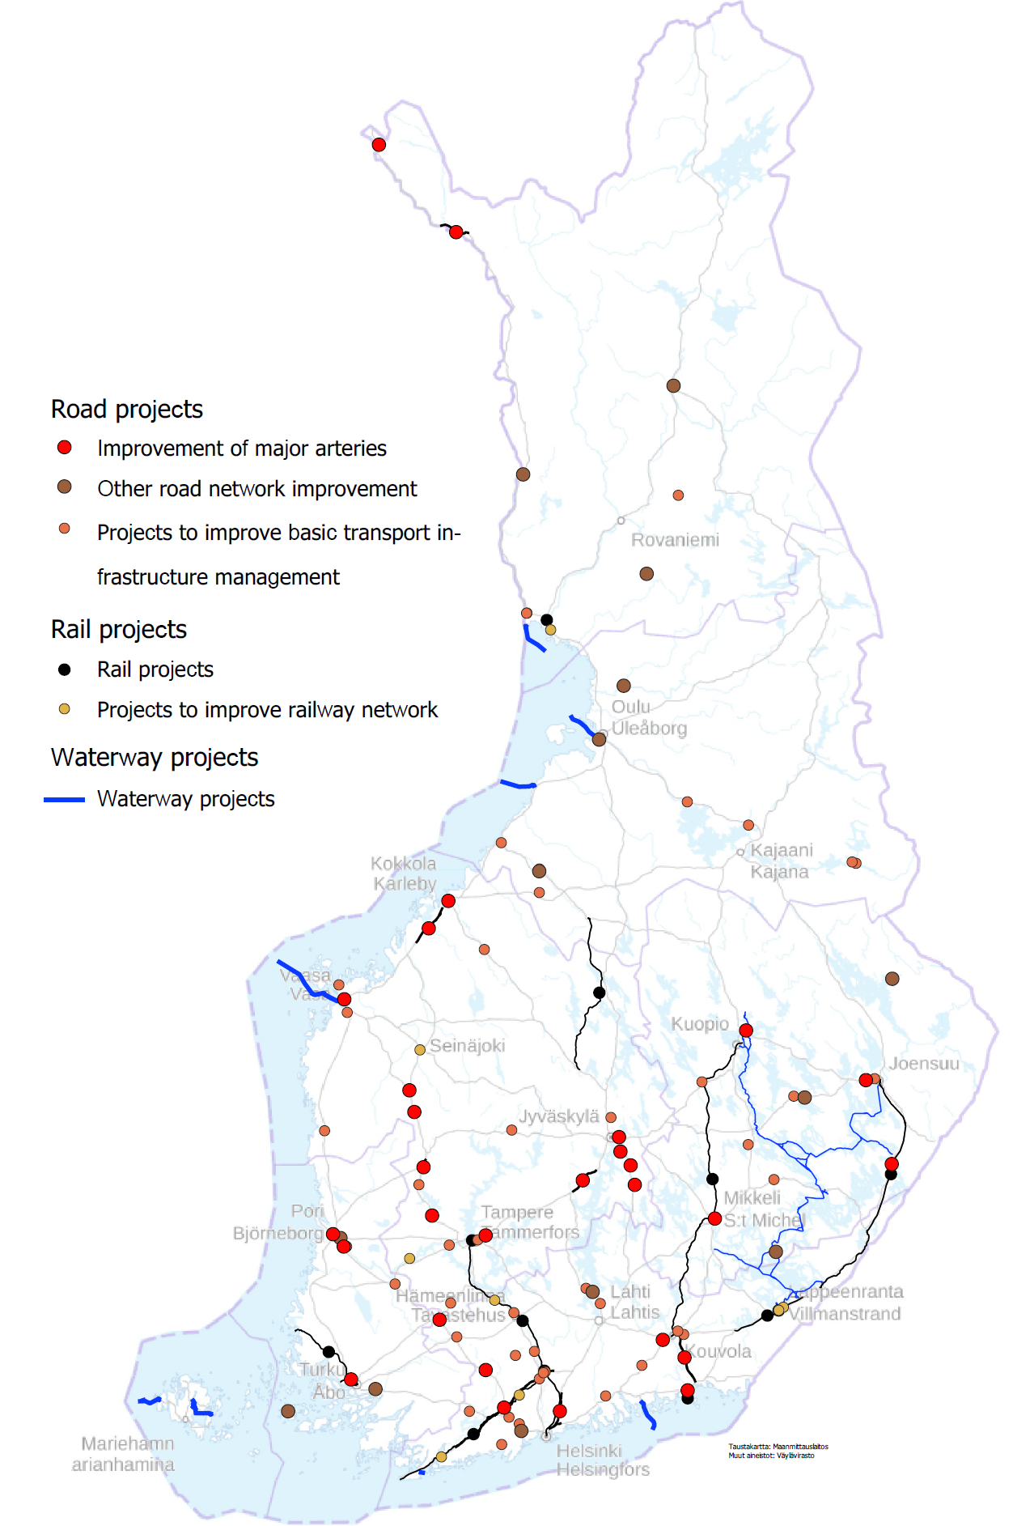
Figure. The investment programme for the state-owned transport network includes railway, road and waterway projects. The names of the railway projects shown on the map can be found in chapter 4.1 of the report, the names of road projects in chapter 4.2 of the report and the names of waterway projects in chapter 4.3 of the report. More detailed descriptions of the projects can be found in the separate reports provided as appendices to the investment programme.

